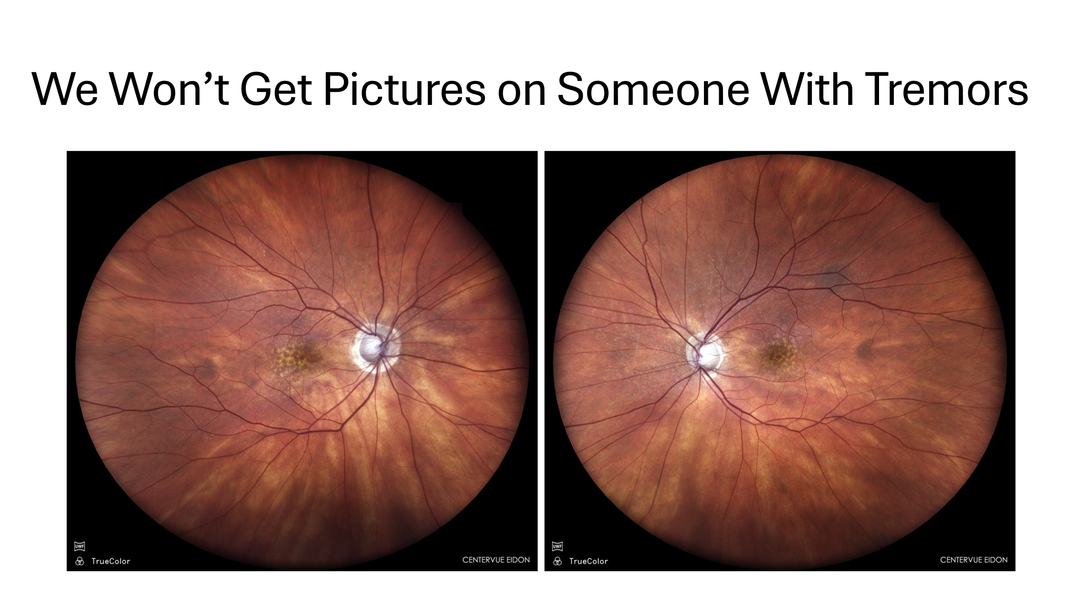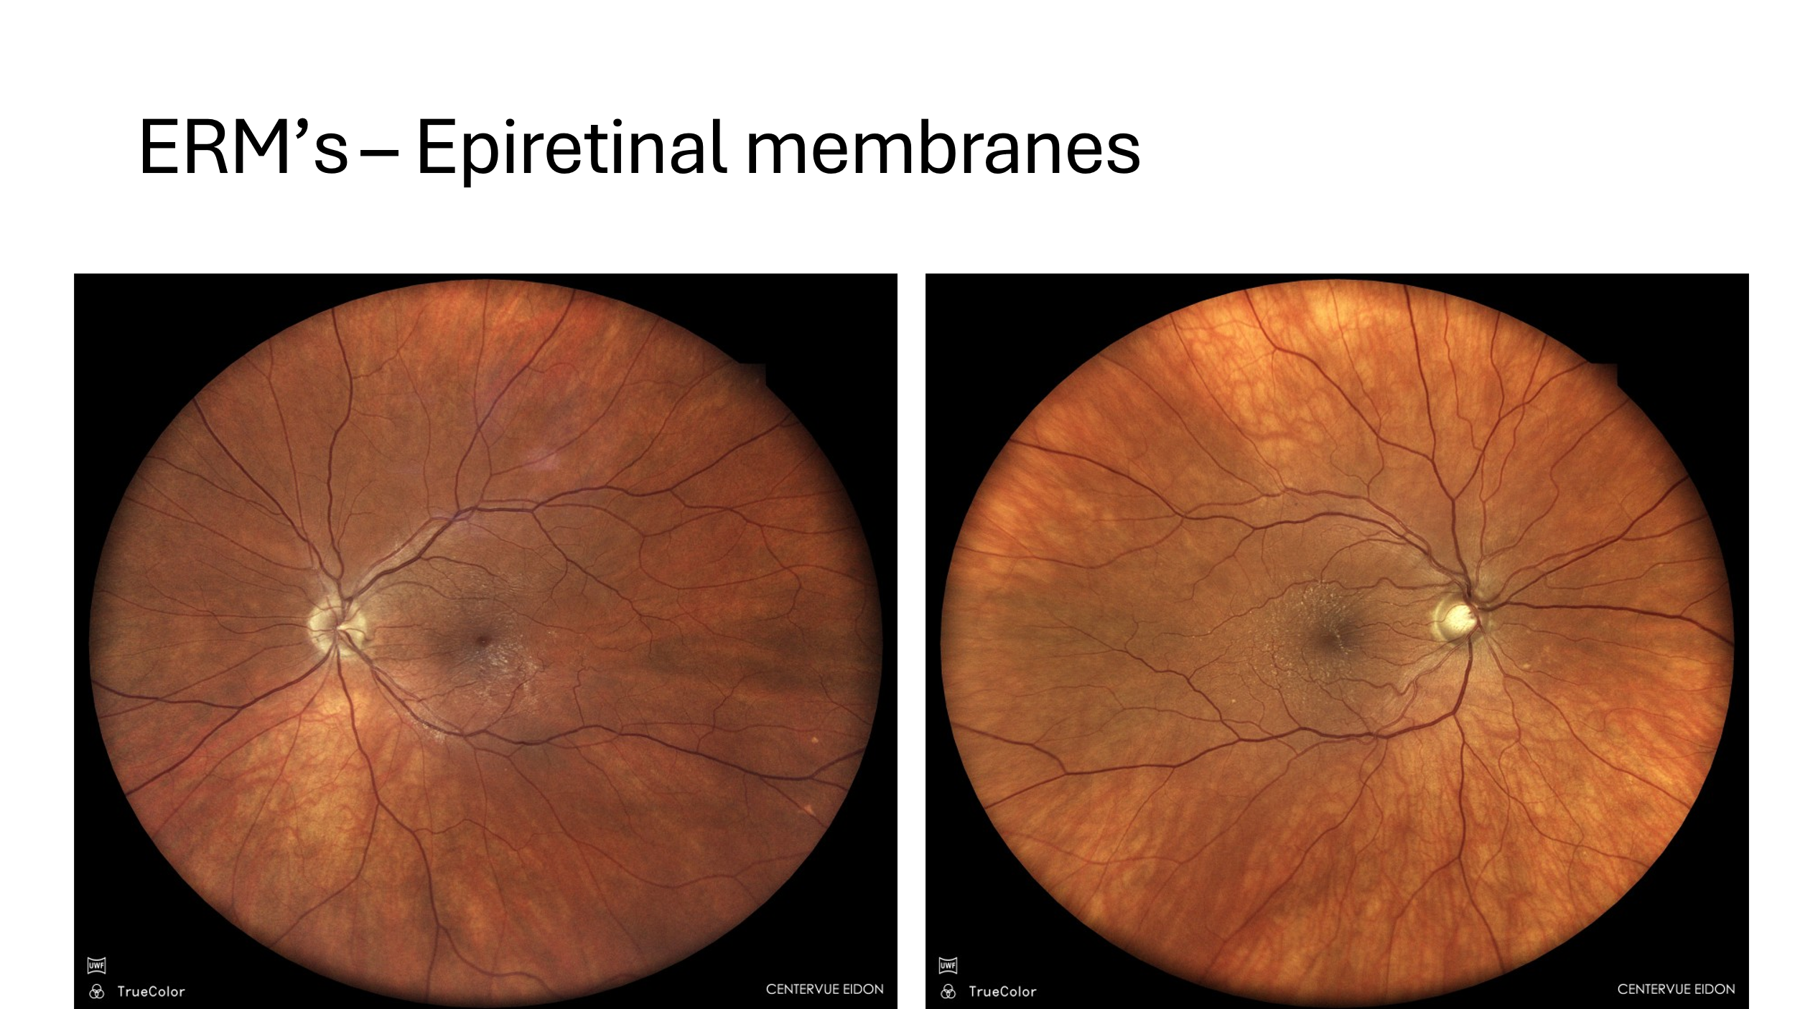

 Eidon UWL Images courtesy of Mile Brujic OD, FAAO